WP2 develops the Policy Intelligence Agent. Its role is to convert Irish and EU climate, energy, AI, infrastructure, and environmental policy documents into structured variables for modelling, scenario testing, and policy analysis.
The policy problem is practical. Ireland has climate and energy targets, but their delivery depends on institutions, timelines, legal authority, reporting duties, enforcement mechanisms, infrastructure capacity, and the ability to adapt to uncertainty. The agent needs to identify not only formal targets but also the governance conditions that affect whether those targets can be implemented.
Exhibit WP2.1 outlines the human-in-the-loop process for building and validating the policy intelligence layer. The PhD student and research support will develop the policy and legal corpus, tag documents with metadata, and apply a coding framework developed with guidance from the senior policy team. The coding framework will identify policy objectives, responsible actors, legal authority, implementation timelines, reporting obligations, review clauses, enforcement mechanisms, data requirements, risk flags, and affected sectors.
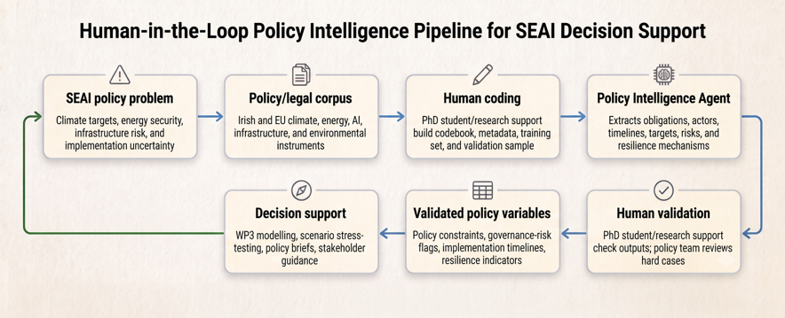
Exhibit WP2.1. Human-in-the-loop policy intelligence pipeline for SEAI decision support. The pipeline starts with SEAI’s policy problem and uses expert-guided coding, AI-assisted extraction, and human validation to generate structured policy variables. These outputs support energy-system modelling, scenario stress-testing, implementation-gap analysis, and policy-facing guidance for Ireland’s climate and energy transition.
A manually coded validation sample will be used to evaluate the Policy Intelligence Agent. The agent will extract obligations, actors, timelines, targets, risks, and resilience mechanisms from policy and legal text. The extracted outputs will be checked against the hand-coded sample. Errors, ambiguous classifications, and missing variables will be logged and used to improve the codebook, prompts, and extraction schema.
The policy team will review difficult classifications, especially when legal authority, institutional responsibility, accountability, enforcement, or implementation risk is unclear. Incorporating domain and policy experts into the evaluation process provides quality assurance and ensures that AI-generated outputs are grounded in expert policy analysis.
The final outputs will be validated policy variables, including policy constraints, implementation timelines, governance-risk flags, institutional responsibilities, accountability mechanisms, and resilience indicators. These variables will support WP3 energy-system modelling, scenario stress-testing, implementation-gap analysis, policy briefs, and stakeholder guidance.
The policy team’s contribution directly strengthens the proposal’s core objective: integrating policy intelligence, emissions analytics, and energy-system optimisation into a decision-support framework for Ireland. The aim is to assess whether a decarbonisation pathway is technically feasible and, equally important, to evaluate its institutional credibility, resilience to shocks, and usefulness for public-sector planning.

